Create an login application having following functionality.

1. User can login if login fails then user must ask for pin with his user name and password.
2. If user fails three times and successfully login using pin no then immediately he should be asked for change his password.
3. Forget password functionality should be work by asking an securty question.
4. Use appropriate database table and its fields,aslo use appropriate control to accomplish that.

Solution:

Login Form

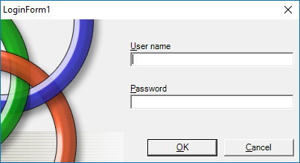

Imports System.Data.SqlClient

Imports System.Data

Imports System.Configuration

Public Class LoginForm1

Dim conString As String = "Data Source=.\SQLEXPRESS;AttachDbFilename=C:\Users\ktrim\Documents\logindb.mdf;Integrated Security=True;Connect Timeout=30;User Instance=True"

Dim con As New SqlConnection

Dim cmd As New SqlCommand

Dim rd As SqlDataReader

Dim count As Integer = 0

Private Sub OK_Click(ByVal sender As System.Object, ByVal e As System.EventArgs) Handles OK.Click

con.ConnectionString = conString

cmd.Connection = con

con.Open()

cmd.CommandText = "select * from login_table where login_username='" & txtusername.Text & "' and login_password='" & txtpassword.Text & "'"

Dim i As Integer = cmd.ExecuteScalar()

If (count > 3) Then

MsgBox("you attend more than 3 time forgot password")

forgetpassword.Show()

Else

If (i <> 0) Then

MsgBox("login sucessfully")

Else

count += 1

MsgBox("invalid username/password!.......")

End If

End If

con.Close()

End Sub

Private Sub Cancel_Click(ByVal sender As System.Object, ByVal e As System.EventArgs) Handles Cancel.Click

Me.Close()

End Sub

End Class

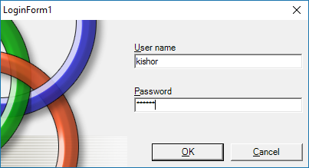

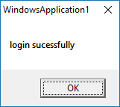

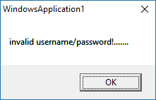

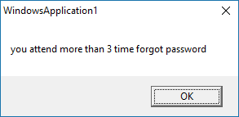

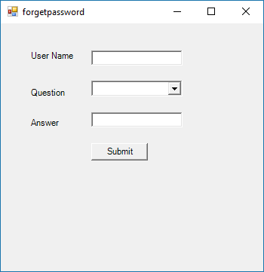

Forget password code:

Imports System.Data.SqlClient

Imports System.Data

Imports System.Configuration

Public Class forgetpassword

Dim conString As String = "Data Source=.\SQLEXPRESS;AttachDbFilename=C:\Users\ktrim\Documents\logindb.mdf;Integrated Security=True;Connect Timeout=30;User Instance=True"

Dim con As New SqlConnection

Dim cmd As New SqlCommand

Dim rd As SqlDataReader

Dim count As Integer = 0

Private Sub forgetpassword_Load(sender As System.Object, e As System.EventArgs) Handles MyBase.Load

con.ConnectionString = conString

cmd.Connection = con

con.Open()

cmd.CommandText = "select * from login_table"

rd = cmd.ExecuteReader()

If (rd.HasRows()) Then

While (rd.Read())

ComboBox1.Items.Add(rd("login_question"))

End While

End If

con.Close()

End Sub

Private Sub btnsubmit_Click(sender As System.Object, e As System.EventArgs) Handles btnsubmit.Click

con.ConnectionString = conString

cmd.Connection = con

con.Open()

cmd.CommandText = "select * from login_table where login_username='" & txtusername.Text & "' and login_question='" & ComboBox1.Text & "' and login_answer='" & txtanswer.Text & "'"

Dim i As Integer = cmd.ExecuteScalar()

con.Close()

If (i <> 0) Then

txtpassword.Visible = True

txtrepassword.Visible = True

Label4.Visible = True

Label5.Visible = True

btnsavechanges.Visible = True

Else

MsgBox("You entered Wrong details!.......")

End If

End Sub

Private Sub btnsavechanges_Click(sender As System.Object, e As System.EventArgs) Handles btnsavechanges.Click

con.ConnectionString = conString

cmd.Connection = con

con.Open()

cmd.CommandText = "update login_table set login_password='" & txtpassword.Text & "',login_repassword='" & txtrepassword.Text & "' where login_username='" & txtusername.Text & "'"

cmd.ExecuteNonQuery()

MsgBox("save changes sucessfully")

con.Close()

End Sub

End Class

